Ideation Phase

Empathize & Discover

|  |  |
| --- | --- |
| Date | June 2025 |
| Team ID | LTVIP2025TMID58213 |
| Project Name | ResolveNow: Your Platform for Online Complaints |
| Maximum Marks | 4 Marks |

Empathy Map Canvas

User Persona: John – A frustrated citizen facing service issues

Thinks Feels

"Will anyone even look at my

Frustrated due to lack of proper response

complaint?"

"I want to help improve the

Anxious about how long the process will take

system"

"Why isn't there an easier way to

Feels neglected and not valued as a citizen

report issues?"

Says Does

Tries to contact officials but receives

"I submitted a complaint but never got a reply"

no updates

"There should be a transparent way to track Takes screenshots, writes long

complaints" explanations

Abandons filing complaints out of

"Nobody is listening to our problems"

disappointment

Pain Points:

* Difficulty in knowing where to file complaints
* Lack of updates and transparency
* Long delays in resolution
* Poor user experience in existing systems

Needs & Goals:

* A user-friendly platform for filing complaints
* Real-time tracking of complaint status
* Interaction with the responsible department/agent
* Trustworthy and responsive system Example:

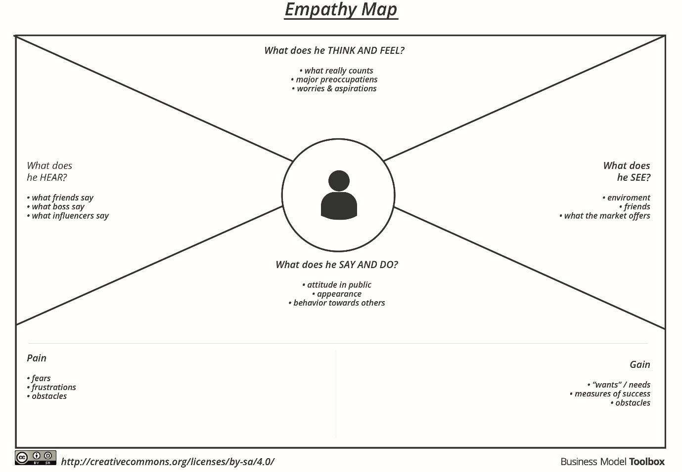

Reference: https://www.mural.co/templates/empathy-map-canvas